**ADDING ANOTHER FORWARDED PORT ON VAGRANTFILE WHEN SERVER IS STILL RUNNING**

FIRST WE HAVE TO MODIFY ***Vagrantfile***

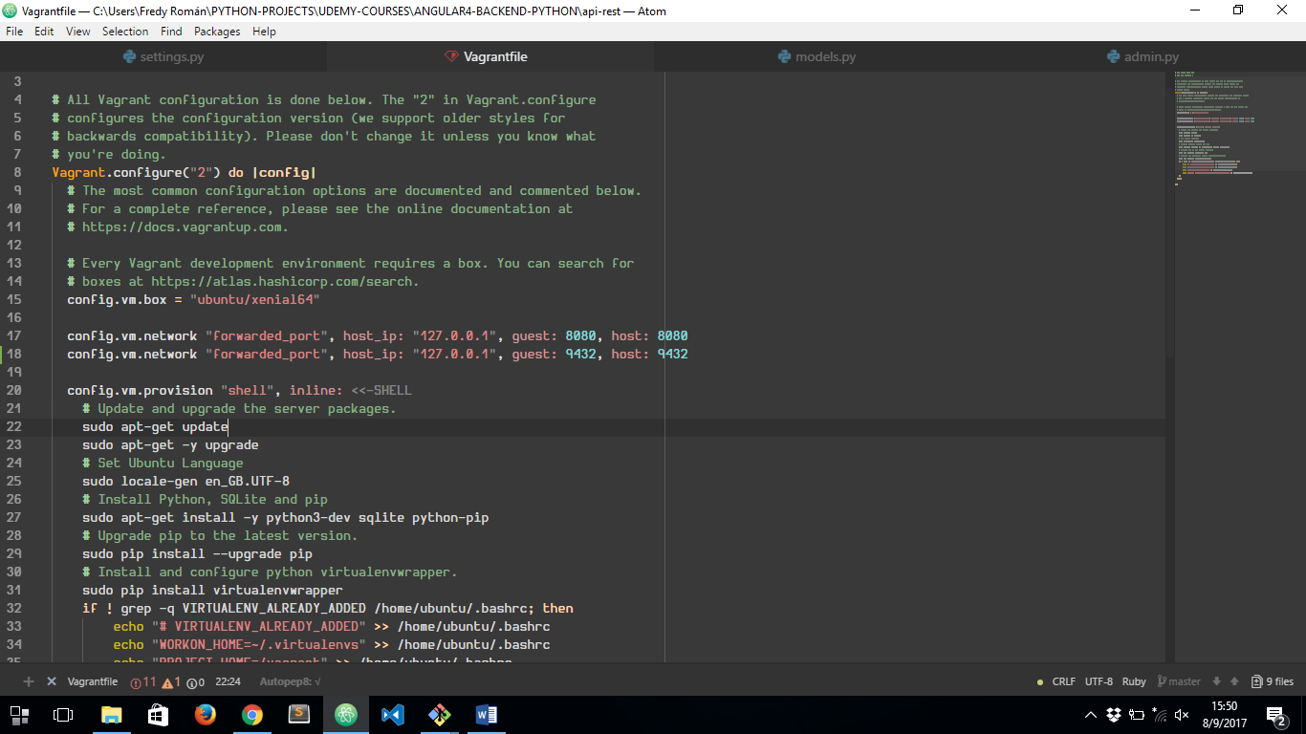

I’VE ADDED A NEW FORWARDED PORT INSIDE THAT FILE

THEN WE HAVE TO CLOSE SERVER INSTANCE ACCESS, AND RUN ***vagrant reload*** ON GIT BASH INSIDE OUR PROJECT FOLDER:

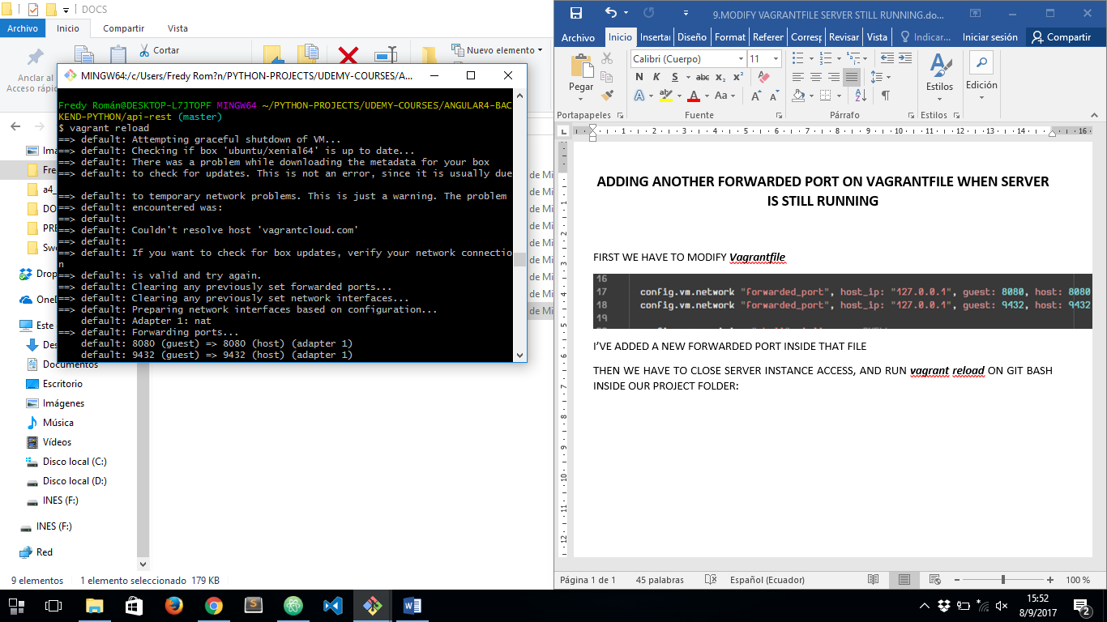

AND THAT’S ALL